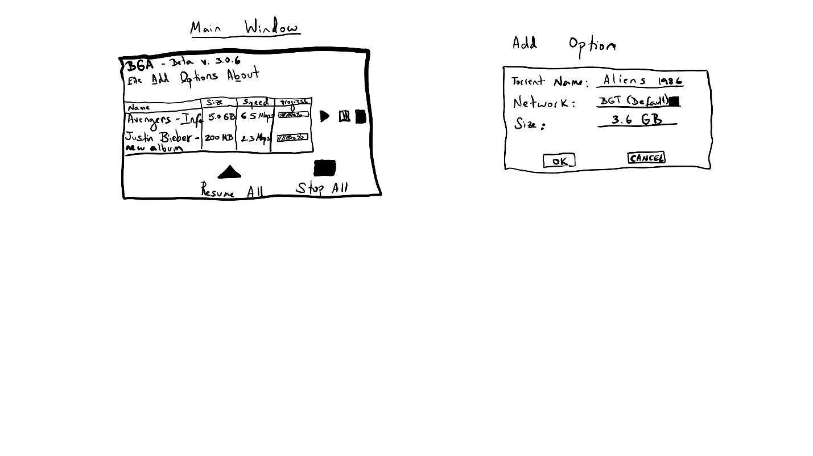

Name: Adam Fanelli

Date: 5/25/2021

Suggestions:

As a user, I’d expect each of the items in the top navigation bar to open a drop-down list with two or more options. If “Add” or “Options”, for example, will only open one other window or provide only one option, maybe consider separating it from the nav bar and making it its own button (i.e., a gear icon for options in the top right corner)

I like how prominent the Resume All and Stop All buttons are. Perhaps just center them and make them slightly smaller or line them up with the list of torrents